**R Tejashree**  
**Superset ID: 6419704**

**WEEK 2 – Assignment Documentation**

* Part A: PLSQL Module
* Part B: TDD (Test Driven Development) with JUnit

**PART A: PLSQL MODULE**

**Step 1: Open SQL Developer**

* Launch **Oracle SQL Developer** from your desktop or start menu.

**Step 2: Connect to the Database**

* Use the connection credentials provided to connect to your Oracle database.
* Example:
  + Username: hr
  + Password: hr
  + Hostname: localhost
  + Port: 1521
  + SID/Service Name: xe

**Step 3: Load and Execute SQL Files**

* Open each of the .sql files provided in the WEEK 2\plsql folder.
* Files include:
  + create_tables.sql – Creates required tables
  + insert_data.sql – Populates the tables with sample data
  + procedures.sql – Contains stored procedures
  + functions.sql – Contains user-defined functions
  + triggers.sql – Contains trigger definitions
  + test_cases.sql – Test the functionality

Note: To run a file, right-click inside the script editor window and select **Run Script (F5)**.

**Step 4: Verify the Outputs**

* Use SELECT queries to verify:
  + Data was inserted successfully
  + Procedures and functions return the expected results
  + Triggers are firing correctly

**Control Structures Outputs :**

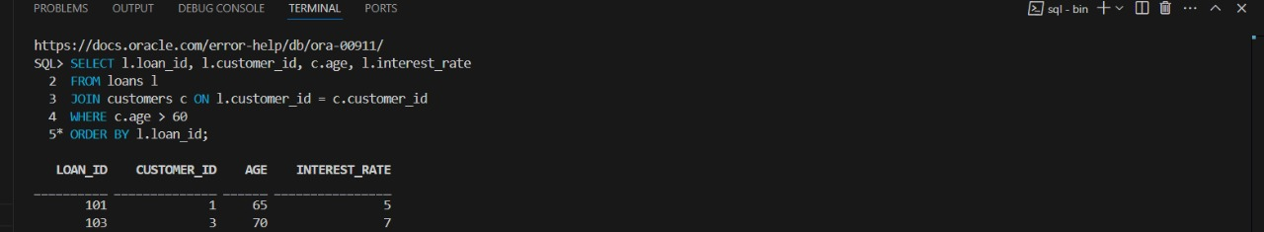

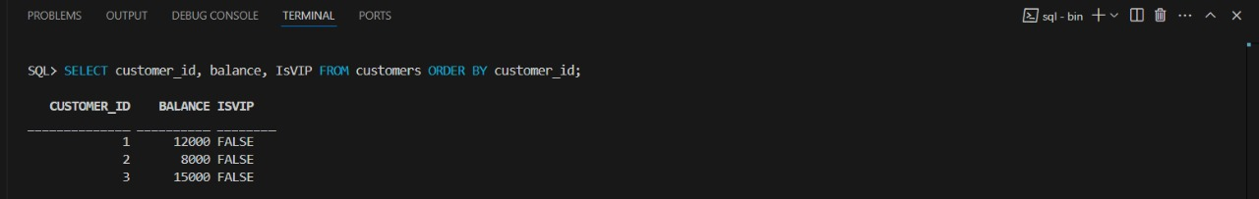

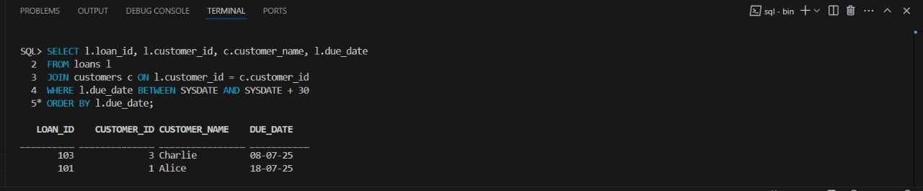

**Stored Structures Outputs :**

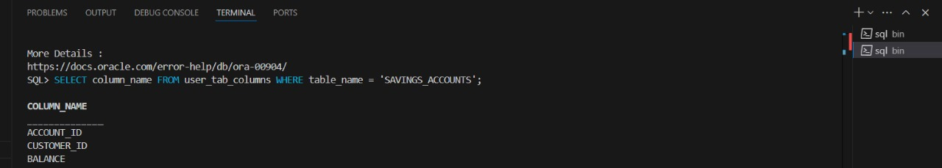

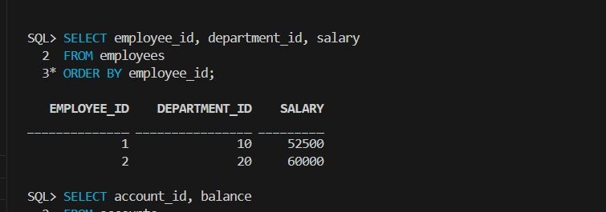

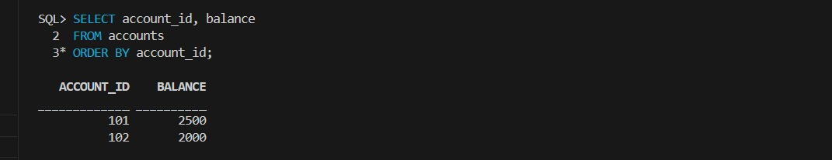

**PART B: TDD (Test Driven Development) Module with JUnit**

**Step 1: Open Eclipse**

* Launch Eclipse IDE with JDK and Maven already configured.

**Step 2: Import the Project**

* Go to **File > Import > Maven > Existing Maven Projects**
* Browse to the path: WEEK 2\tdd
* Select the project folder and click **Finish**

**Step 3: Explore Project Structure**

* Key folders:
  + src/main/java – Contains the source code
  + src/test/java – Contains the JUnit test cases

**Step 4: Review the Code**

Example: Calculator.java

public class Calculator {

public int add(int a, int b) {

return a + b;

}

}

Example: CalculatorTest.java

import static org.junit.jupiter.api.Assertions.*;

import org.junit.jupiter.api.Test;

public class CalculatorTest {

@Test

public void testAdd() {

Calculator calc = new Calculator();

assertEquals(5, calc.add(2, 3));

}

}

**Step 5: Run JUnit Tests**

* Right-click the test file or project
* Select **Run As > JUnit Test**
* Ensure all test cases pass (green bar in JUnit window)

**Outputs:**

**EX 1 Settingup Junitdemo**

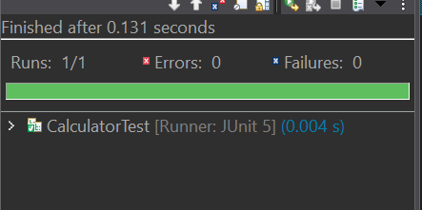

**EX 2 AssertionsTest**

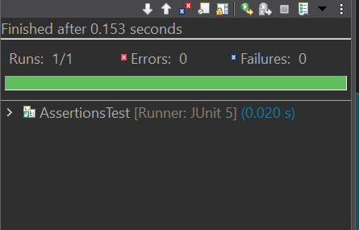

**EX 4 AAA**

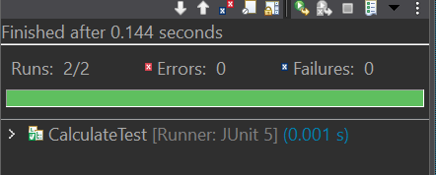

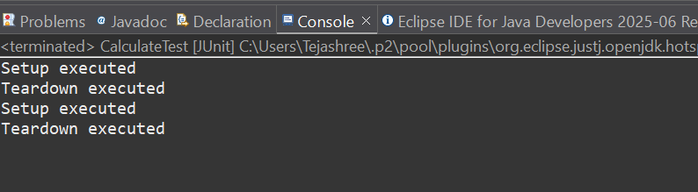

**MOCKITO EXERCISES**

**EX-1 MOCKING & STUBBING**

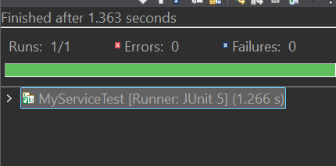

**EX-2 VERIFYING & INTERACTIONS**

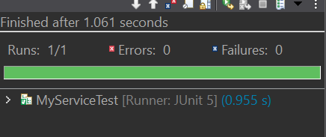

**SLF4J LOGGING FRAMEWORK**

